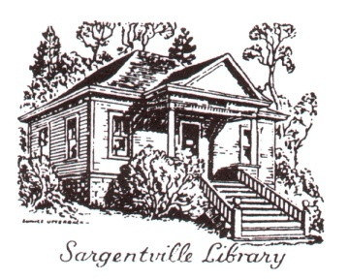

Sargentville Library Association
PO Box 233, Sedgwick ME 04676
www.sedgwickmaine.org/content/view/172/41

Newsletter

Winter 2017
_________________________________________________________________________________

Winter greetings to our Sedgwick community

Our BIG NEWS is the introduction of our Historical Archive, first introduced by Pam Simmons in an August 2016 program. Coverage by the Weekly Packet followed in December and announced “the launch of a digital Historical Archive on the Town of Sedgwick’s web page. Those interested can visit http://www.sedgwickmaine.org/sargentville-library-historical-archive/ The link will go to the archive where one can search the database for historical information related to the Village of Sargentville and the Town of Sedgwick.” (Weekly Packet, 12/15/2016). Comments or questions about the archive can be sent to sargentvillelibraryarchive@gmail.com. The archive represents at least five years of hard work by many year round and summer members of the Sedgwick community. See the photo and document included in this newsletter offered as samples of the 1683 pages of material included in the archive.

Other accomplishments this year include removal of the documents room, added to the library in the 1960s. It had become too damp for storage of library documents and books. Now we have a back door which opens to the outdoors. We also started renting a porta-potty for the summer months, accessible through the new door. Our public event, An Evening of Local History, occurred in August and featured Pam Simmons unveiling the Archive described above and Kevin Johnson introducing the Penobscot Marine Museum’s new book, Maine on Glass. We were thrilled to host a large crowd in the Sargentville Chapel. Cathy Marshall again organized our book group last summer and we discussed the following: The Wild Truth, McCandless and In the Kingdom of Ice, Sides.

Looking forward to the summer

We are exploring various options for one summer community program to focus on local history or topics of particular interest to our area of Maine. We are also hoping to introduce a Little Free Library to the community and participate in the Touring Through Time week-end in late July. Meanwhile, check out our past newsletters on the Sedgwick town website (www.sedgwickmaine.org/content/view/172/41) and enjoy a pleasant winter and spring.

Samples of an archive photo and the opening sentences of one document:
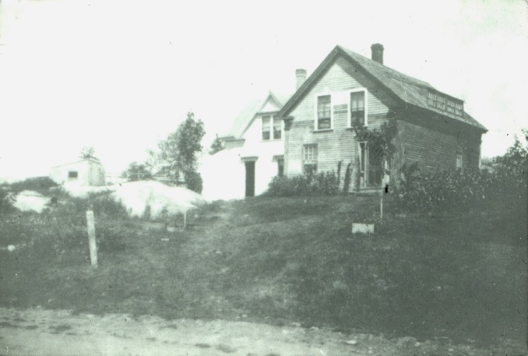 | This is an early photo of the home of Robert and Rada Starkey. It is believed that the left section of the building was built by Wyer G. Sargent in 1847 and used as a meeting room, called Rio Hall, for the Sons of Temperance Rio Grande Division No. 63. It is also said that Andrew Cooper had a blacksmith shop on the first floor and that at least a portion of this house was moved here from Lazy Corner

A Sketch of Edward Brown's Cruise on the Frolick
November the 18, 1813, I shipped on board the Frolick United States sloop of war, which carried twenty guns: eighteen thirty two pound cannonades, two long eighteens. … We had the intention of breaking up the blockade off the Belies, off the mouth of the Mississippi, but unhappily the second day out we were chased by a British line battle ship. When within a gunshot and a half our commander cried "cut away the sheet anchor, throw over the spare cordage, slack up the rigging, slack up the lee rigging, start the water……..

Library Association Officials:
President Diana Marston Wood
Vice President Robert Starkey
Secretary Cathy Marshall
Treasurer Emily Webb
Trustees Kay Grover
Linda Long
Jan Anderson
Rada Starkey
Pam Simmons, Chair, Archive Committee
Librarian Kay Grover

The Sargentville Library Association is a non-profit 501(c)(3) Corporation, incorporated in Maine June 21, 1905.

